AGORA
Strategy Research
Does a trading rule survive an honest test?
Seven trading rules, twelve companies, ten years of daily prices, and a backtest engine built so that it cannot see the future.
Investment portfolio. September 2026.
The coding was done with the help of AI, because coding is not my strong area. I set the direction, made the decisions and checked the results.

1. What this is
Agora started as a market simulator, a crowd of small software traders whose orders make the price. It has grown into a place to test trading rules properly, on made up markets and on real ones, with the same engine for both.
This report asks one question. When a simple trading rule looks good in a backtest, how much of that survives an honest test? The short answer is not much. The best rules looked almost as good as buying and holding when their settings were picked with hindsight, and every rule fell well short once the settings had to be chosen without knowing the future.
The first version of this report tested each rule once, over the whole ten years, with fills at the same closing price that triggered the signal. That is how most quick backtests are done, and it flatters them. This version rebuilds the engine around a strict time frontier, a realistic execution model and a proper account, and then tests every rule four different ways.

2. How the engine works

Four parts, one rule
The engine is split the way professional backtesting systems are. Market data supplies bars. The strategy engine turns bars into signals. The market simulator makes synthetic markets for stress tests. The strategy tester runs experiments and measures them. The one rule that holds it together is that a strategy never knows where its prices came from. A real company, a real index and a synthetic crash all arrive as the same open, high, low, close and volume bars, so the same rule runs on any of them without a single change.

The time frontier
This is the most important change. The engine walks through history one bar at a time. A bar only reaches the strategy once it has closed, and any order the strategy sends waits for the next bar and is filled at its open. At 10.35 a strategy knows the 10.35 close and nothing after it. It cannot trade at a price it has not seen yet.
Saying so is easy, so the engine is tested for it. One test runs a strategy on ten years of Microsoft, then runs it again with everything after a cut off date deleted, at four different cut offs. The trades and the account before each cut off are identical to the last digit. If the engine had leaked any future information, deleting the future would have changed the past. Another test hands a strategy a way to ask for tomorrow’s price and checks that the engine refuses. All twelve engine tests pass.
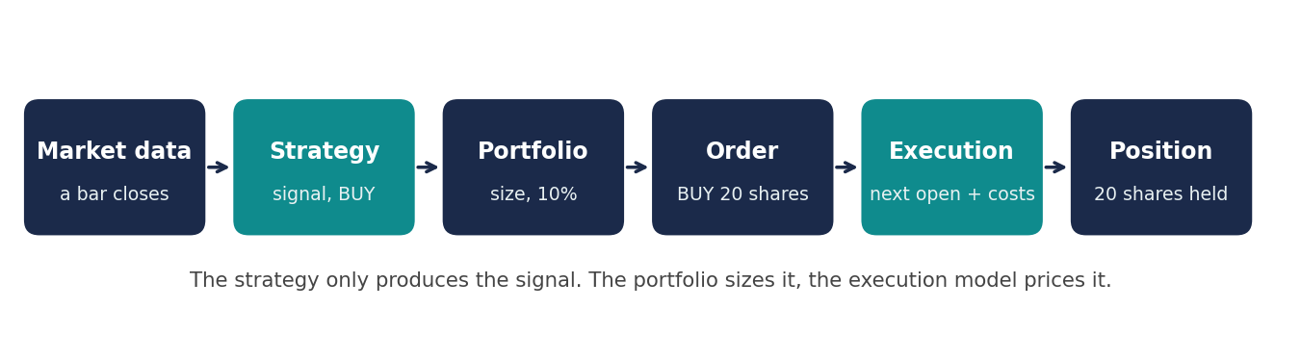
Figure 1. The chain from a closed bar to a position. The strategy only says BUY. The portfolio decides how much, and the execution model decides the price and the costs.

Which price the tester uses
Share prices get rewritten after the event. A 4 for 1 split makes an old price look four times higher than the new one, and the dividend adjusted series quietly changes every past price whenever a dividend is paid later. Using that adjusted series for trading decisions is a known way to leak the future into a backtest.
So the tester trades on split adjusted prices, where every percentage move is the real one, and it pays dividends into the account as cash on the day the share goes ex-dividend. The account still earns the full total return, but no decision is ever made on a number that did not exist at the time. Times are stored in each exchange’s own time zone, a bar is labelled by when it starts, and any bar that has not finished yet is dropped when the data is downloaded.

Orders, fills and costs
The strategy produces a signal, not a trade. The portfolio sizes it (all in, a fixed share of the account, a fixed amount, or a size set by volatility) and caps it (most in one asset, most leverage, whole shares only). The execution model then fills it at the next open and adds four costs. Buyers pay half the bid and ask spread (5 basis points wide by default), slippage moves the price a little further against them, large orders push the price using the square root rule for market impact, and commission is charged at 0.05% with a minimum of 1. No order may be bigger than 10% of the average daily volume.
A real example from the Microsoft test shows how it reads. The rule said buy on 2016-12-06 because the fast average (60.00) had crossed above the slow one. The order was for 1,653 shares. The open was 60.43, and the fill came to 60.4570 after the spread, slippage and impact. On top of that came 49.97 of commission. The order was 0.0056% of a normal day’s value traded, so the market impact was tiny, 9.71 in total.

The account
The account is kept the way a broker keeps it, with cash, positions, the average price paid, realised and unrealised profit, exposure and leverage. It can hold many assets at once, it can go short, and a short that runs against it gets a margin call when equity falls below 25% of what is held. Section 4.5 uses this to run one rule across all twelve companies at once.

3. How the rules were tested
The seven rules are buy and hold, a moving average cross, RSI mean reversion, momentum, mean reversion around an average, a channel breakout, and buy the dip. They were run on twelve large companies (AAPL, MSFT, NVDA, TSLA, AMZN, GOOGL, JPM, WMT, KO, BA, XOM, JNJ) over ten years of daily prices, from September 2016 to September 2026, starting with 100,000 and paying all the costs above.
Each rule went through four methods. A plain historical backtest runs the whole period with the default settings. An out-of-sample test picks the best settings on the first 70% of the history, freezes them, and judges them on the last 30%, which the optimiser never saw. A walk-forward test does that again and again, training on three years, testing on the next one, then moving on a year, so every test year is judged with settings chosen only from the years before it. A stress test runs each rule on six synthetic markets built to be one clear kind of market each.
Everything is compared with the S&P 500 Total Return index, which puts dividends back into the index. The better known S&P 500 leaves them out, and comparing a strategy that collects dividends with an index that does not would flatter the strategy by one to two points a year.
The web page runs the same tests in the browser. Its engine is a line by line copy of the Python one, and a parity test runs eight different experiments through both and checks that every number matches. They do, so the page and this report can never tell different stories.

4. Results

4.1 The hindsight test against the honest test
The fairest way to see overfitting is to look at the same years two ways. The grey bars below are the best result each rule could have shown if its settings had been picked after seeing those years, the sort of number that ends up in a quick backtest. The teal bars are the walk-forward result over exactly the same years, where the settings had to be chosen in advance. On average the honest result was 7.0% a year lower.
Rule | Best with hindsight | Walk-forward | Buy and hold, same years | Beat buy and hold | Against S&P 500 TR
Buy and hold | +24.3% | +24.8% | +24.3% | 10 of 12 | +8.3%
Moving average cross | +22.3% | +13.9% | +24.3% | 0 of 12 | -2.6%
RSI mean reversion | +14.8% | +8.4% | +24.3% | 0 of 12 | -8.1%
Momentum | +22.2% | +14.1% | +24.3% | 2 of 12 | -2.3%
Mean reversion | +10.2% | +5.9% | +24.3% | 1 of 12 | -10.6%
Breakout | +15.7% | +10.5% | +24.3% | 1 of 12 | -6.0%
Buy the dip | +23.5% | +13.9% | +24.3% | 1 of 12 | -2.6%
Table 1. Average yearly return across the twelve companies, September 2019 to September 2026 (the years the walk-forward test traded). The last two columns count companies and give the average yearly gap to the index.
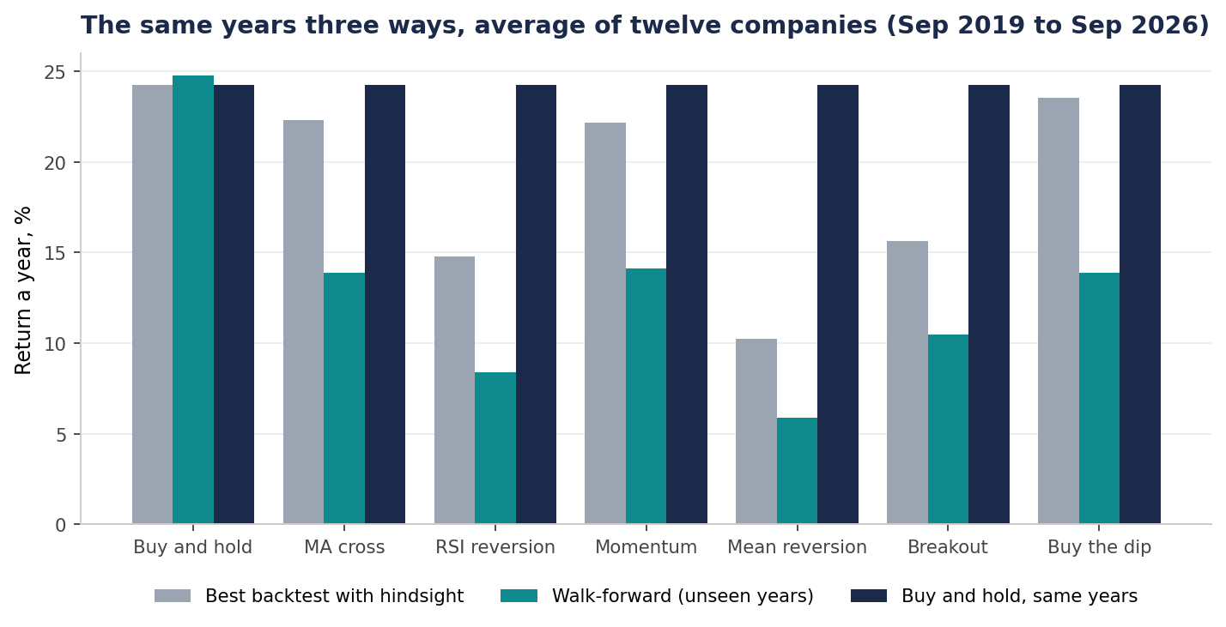
Figure 2. The same seven years three ways.
That gap is the whole story of this report. With hindsight, the moving average cross made +22.3% a year and momentum +22.2%, close enough to buy and hold (+24.3%) to look like a real alternative with less risk. Tested honestly they made +13.9% and +14.1%. No active rule beat buying and holding on more than 2 of the twelve companies. The best of them, momentum, still trailed the S&P 500 Total Return by 2.3% a year.
The walk-forward efficiency (the unseen return divided by the return the optimiser found in training) had a median between 0.49 and 0.68 across the rules. Between a third and a half of what looked like an edge in training did not survive contact with unseen years.

4.2 Out-of-sample decay
The single train and test split tells a similar but noisier story. The trend rules lost most. Momentum’s Sharpe ratio fell from 0.80 on the training years to 0.42 on the test years, and the moving average cross from 0.72 to 0.55. The rules that buy weakness did the opposite. Buy the dip went from 0.79 to 0.94 and mean reversion from 0.53 to 0.75.
That is not proof that dip buying is the better idea. The test years, late 2023 to 2026, were a strong market with sharp but short falls, which is exactly the world a dip buyer likes. One split is one roll of the dice, and that is why the walk-forward test, with seven separate test years, carries more weight in this report.
Rule | Training Sharpe | Test Sharpe | Training return a year | Test return a year | Held up
Moving average cross | 0.72 | 0.55 | +18.9% | +11.3% | 6 of 12
RSI mean reversion | 0.67 | 0.70 | +12.9% | +12.8% | 8 of 12
Momentum | 0.80 | 0.42 | +19.3% | +7.2% | 6 of 12
Mean reversion | 0.53 | 0.75 | +8.2% | +11.3% | 9 of 12
Breakout | 0.63 | 0.55 | +14.5% | +9.6% | 5 of 12
Buy the dip | 0.79 | 0.94 | +20.0% | +22.6% | 9 of 12
Table 2. Trained September 2016 to September 2023, tested September 2023 to September 2026. "Held up" counts companies where the test Sharpe kept at least 70% of the training Sharpe.
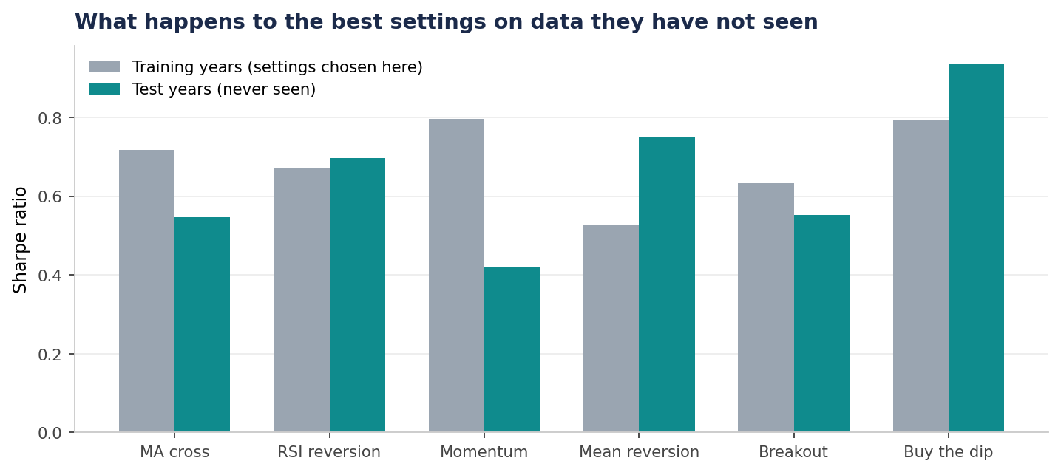
Figure 3. The best settings on the training years, judged on years they had not seen.

4.3 Costs and fill timing
These daily rules trade rarely, around 27 round trips in ten years for the moving average cross, so costs did less damage than I expected. Raising slippage from nothing to 0.25% a trade took about 1.5% a year off the moving average cross and 1.6% off mean reversion. Buy and hold barely noticed. Over the full ten years, costs still added up to between 6.9% and 14.7% of the starting account for the active rules, money that buy and hold keeps.
The picture changes completely at high frequency. When I tried the RSI rule on the web page, on one week of Apple 1 minute bars, it made 29 round trips and paid 5% of the account in costs, turning a small edge into a loss while buy and hold was up. Costs decide whether a busy rule works at all.
Rule | No slippage | 0.01% | 0.05% | 0.10% | 0.25%
Buy and hold | +22.6% | +22.6% | +22.6% | +22.6% | +22.6%
Moving average cross | +10.0% | +10.0% | +9.7% | +9.4% | +8.5%
RSI mean reversion | +8.6% | +8.5% | +8.3% | +8.0% | +7.1%
Momentum | +10.2% | +10.2% | +9.9% | +9.6% | +8.6%
Mean reversion | +5.0% | +4.9% | +4.7% | +4.3% | +3.4%
Breakout | +9.1% | +9.0% | +8.8% | +8.5% | +7.5%
Buy the dip | +14.0% | +13.9% | +13.8% | +13.6% | +12.7%
Table 3. Average yearly return of the historical backtest at five levels of slippage, all other costs unchanged.
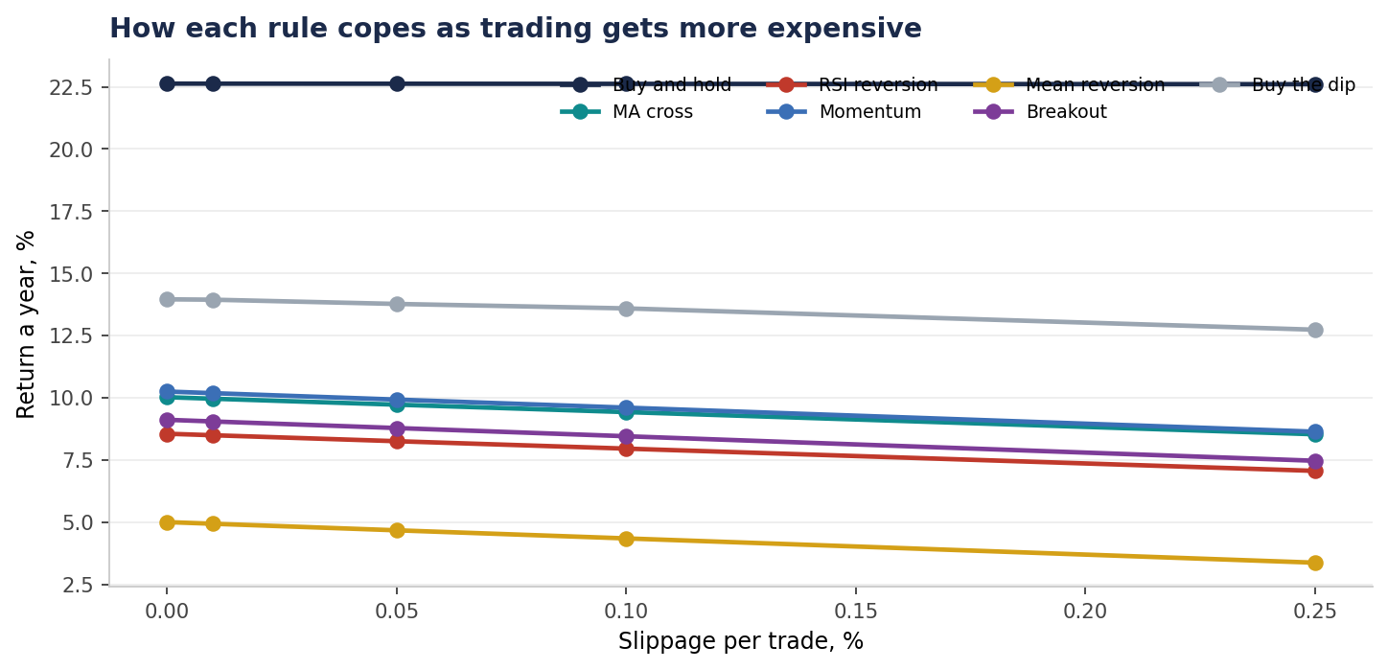
Figure 4. Return a year as slippage rises.
Filling at the same close instead of the next open made less difference than the textbooks suggest, and not always in the rule’s favour. RSI reversion gained +0.43% a year from the optimistic fill, because it buys on a weak close and the next open has often already bounced. Mean reversion lost -0.79%. The honest fill is still the right one. The point is that the size of the flattery depends on the rule, so it cannot just be assumed away.

4.4 Stress tests
The synthetic markets split the rules into two families that mirror each other. The trend rules (moving average cross, momentum and breakout) earned their keep in the bad markets. In the crash they made between +25% and +29% while buy and hold lost 8%, and in the slow bear market they lost around a third as much as buy and hold. The price was sideways markets, where they were whipsawed and lost between 13% and 17%.
The rules that buy weakness (RSI, mean reversion and buy the dip) were the reverse. They made money in the sideways market, up to +24%, and were hurt most by the crash, where buying every fall means catching a falling knife. Mean reversion lost 39% there.
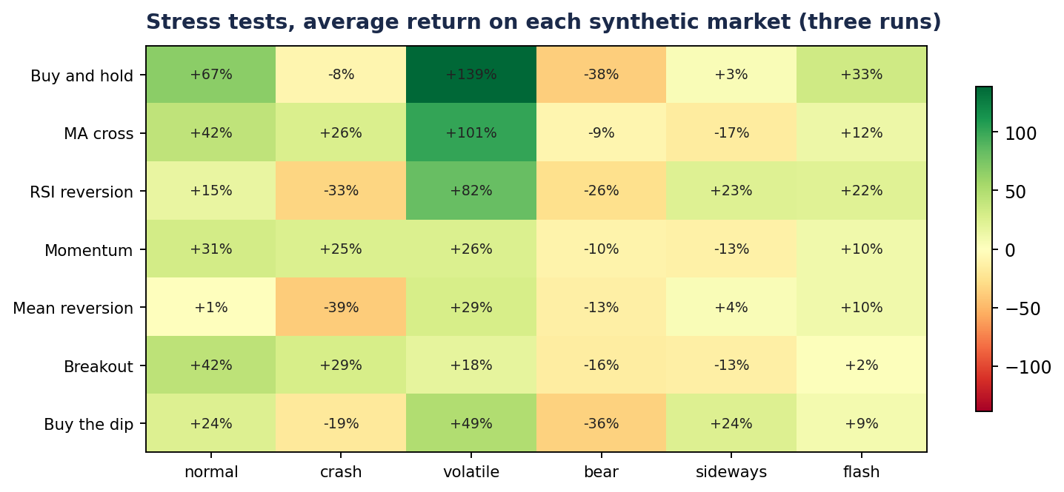
Figure 5. Average return on each synthetic market, three runs each with different random draws.

4.5 One rule across twelve companies
Run on one share at a time, the active rules looked poor. Spread across all twelve companies at once, with 10% of the account in each new position and no more than 20% in any one company, they looked quite different. The moving average cross made +16.4% a year with a Sharpe ratio of 1.05 and a worst fall of -28.8%. The S&P 500 Total Return made +15.6% over the same years. So the portfolio kept pace with the market, but with a beta of only 0.59, because on average about 27% of the account sat in cash while the rule waited for trends.
Equal weight buy and hold of the same twelve made +34.1% a year. That number should not be believed. These twelve are household names today precisely because they did well, and I picked them knowing that. Any rule tested on today’s winners inherits that hindsight, which is called survivorship bias and is the biggest single limit of this study.
Portfolio | Return a year | Sharpe | Worst fall | Beta | Costs
Moving average cross, 10% each | +16.4% | 1.05 | -28.8% | 0.59 | 14.1%
Momentum, 10% each | +16.0% | 1.05 | -28.5% | 0.55 | 15.5%
Buy and hold, equal weight | +34.1% | 1.13 | -47.9% | 1.35 | 0.1%
S&P 500 Total Return | +15.6% |  |  | 1.00
Table 4. One account holding up to twelve positions, September 2016 to September 2026. Costs are the total over ten years as a share of the starting account.
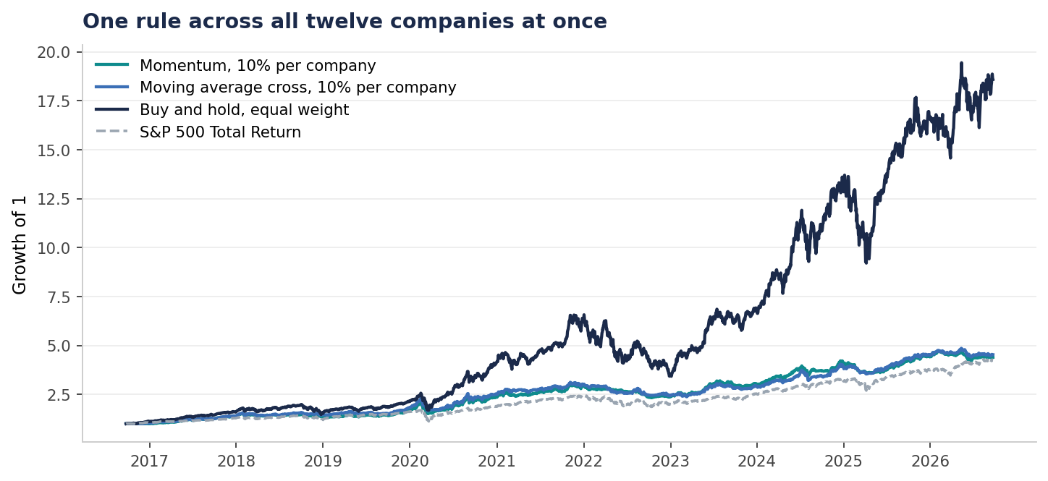
Figure 6. Growth of 1, one rule across the whole basket.

4.6 A worked example, Microsoft
The walk-forward test on Microsoft shows how the method works year by year. The optimiser re-chose the moving average settings each September using the three years before. It changed its mind several times, and in the years where it sat out of the market, like 2022, that helped. In the years where it missed a rally, like the year to September 2021, it hurt a lot. Over the seven years it made +8.5% a year against +20.8% for simply holding Microsoft, with a walk-forward efficiency of 0.31.
Tested on | Settings chosen | Test return | Index | Test Sharpe
2019-09-27 to 2020-09-25 | fast 30, slow 50 | +18.1% | +13.5% | 0.63
2020-09-28 to 2021-09-27 | fast 10, slow 50 | -1.6% | +34.5% | 0.00
2021-09-28 to 2022-09-27 | fast 30, slow 200 | +3.5% | -14.9% | 0.28
2022-09-28 to 2023-09-28 | fast 20, slow 200 | +18.8% | +17.6% | 1.01
2023-09-29 to 2024-09-30 | fast 30, slow 200 | +36.9% | +36.4% | 1.70
2024-10-01 to 2025-10-02 | fast 30, slow 200 | +0.8% | +19.2% | 0.13
2025-10-03 to 2026-09-24 | fast 20, slow 200 | -10.3% | +16.0% | -0.84
Table 5. Each row is one unseen test year. The settings were chosen on the three years before it.
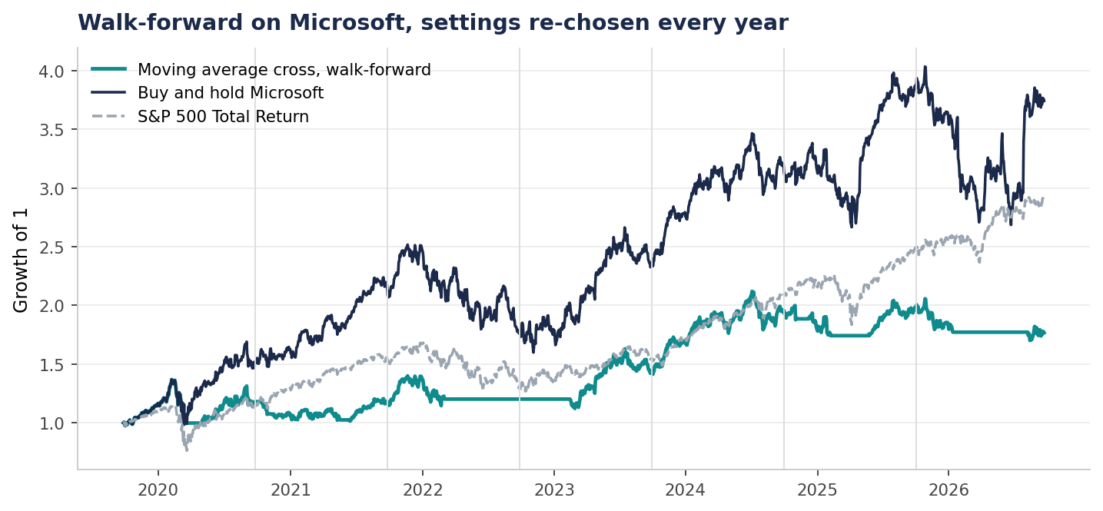
Figure 7. The walk-forward record on Microsoft. Thin grey lines mark where the settings were re-chosen.
The settings map is the other useful check. It shows the Sharpe ratio of every setting in the grid over the whole ten years. A broad area of similar results means the rule is not balanced on one lucky choice. For Microsoft the area is broad, most settings land between 0.6 and 1.0, which is reassuring about the rule even though it still lost to holding the share.
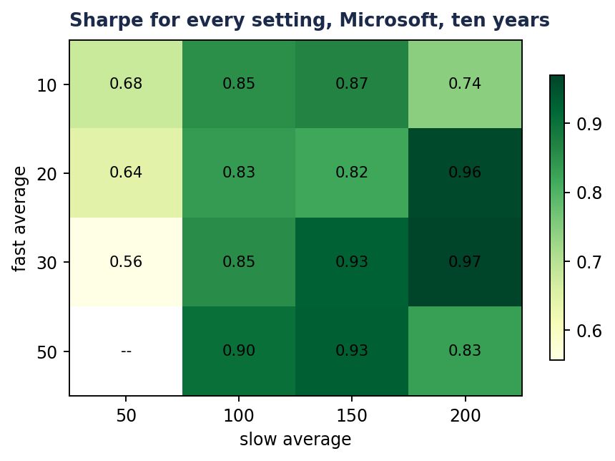
Figure 8. Sharpe ratio for every setting of the moving average cross on Microsoft.

5. What the numbers say
The strongest finding is the gap between the hindsight backtest and the walk-forward test. It was large for every rule, and it is the gap that separates a strategy that looks good from one that is good. Anyone judging a rule from a single backtest with tuned settings is mostly measuring their own hindsight.
The second finding is that no simple rule here was a better way to own these shares than owning them. That is no surprise given the period. Ten years of a strong, mostly rising market is the hardest possible test for a rule whose main skill is stepping aside.
The fair case for the rules is real though. The trend rules did what they claim, cutting the damage in crashes and bear markets, and spread across many shares they matched the market with much lower beta and a smaller worst fall. Someone who cannot stomach a 45% fall might reasonably accept a lower return for that. The sensible conclusion is not that these rules are useless. It is that they are insurance with a cost, and the cost in a bull market is large.
Finally, the two rule families mirror each other in the stress tests. That suggests the obvious next step, a portfolio that holds both a trend rule and a reversion rule, so that each covers the market the other hates.

6. Honest limits
Survivorship bias is the biggest. The twelve companies were chosen in 2026 as well known large firms, which means they were chosen because they survived and grew. A fair test would use the companies that were large in 2016, including the ones that later fell away. The data for that is not free, so the results for buy and hold in particular are too good.
The period is one market regime. Almost all ten years were a rising market with short, sharp falls. The synthetic stress tests help, but they are simple and controlled on purpose, so they show how a rule copes rather than what it would earn.
The execution model is a model. Spread, slippage and impact are assumptions, not measured from real order books, because free bid and ask history is not available. Filling at the open also assumes the order gets the opening price plus costs, when in reality the opening auction has its own quirks. Dividends are paid as cash and sit in the account rather than being reinvested, taxes are ignored, and shorts pay no borrowing fee.
The walk-forward windows (three years to train, one to test) were my choice, and different windows would give somewhat different numbers. Intraday data covers only the last week at one minute and two months at one hour, so it is a demonstration, not a basis for conclusions.

7. What it shows
This project shows how to build a backtest that deserves some trust, which is harder and more useful than building one that produces a good number. It covers the separation of signal, order and fill, a strict time frontier tested by deleting the future, careful handling of splits and dividends, a realistic cost and liquidity model, a proper multi asset account, and the methods (out-of-sample, walk-forward and stress testing) that stop a researcher fooling themselves.
The code was written with the help of AI, because coding is not my strong area. I designed the system, made the decisions about what to build and why, questioned the results that looked too good (which is how the unfair backtest comparison and the misleading trade statistics were caught and fixed), and wrote this report.

